Nguyễn Bảo Chương - 20146481

Homework week2

Bài 1:

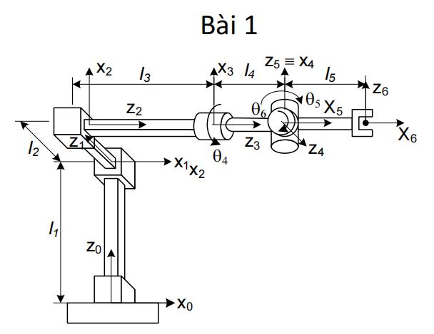 .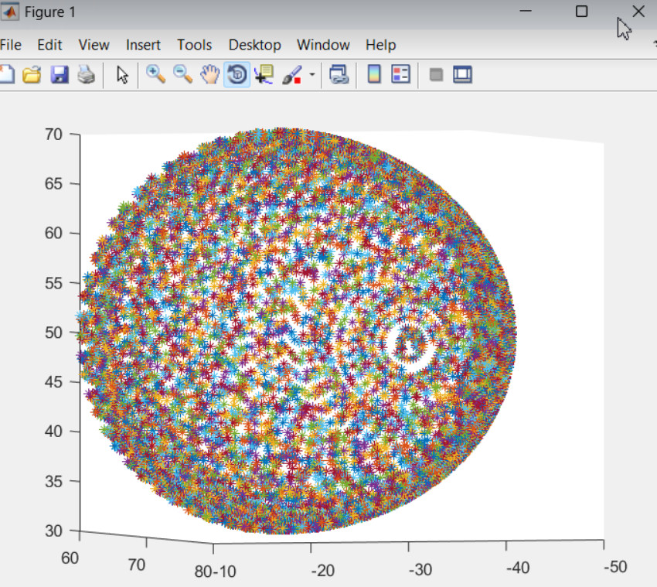

P=T(0,0,l1).R(x,90).T(0,0,l2).R(z,90).R(x,90).T(0,0,l3).R(z,t4).T(0,0,l4).R(x,t5).R(z,t6).T(l5,0,0).P4

[ sin(t5)\*sin(t6), cos(t6)\*sin(t5), cos(t5), l3 + l4 + l5\*sin(t5)\*sin(t6)]

[- cos(t6)\*sin(t4) - cos(t4)\*cos(t5)\*sin(t6), sin(t4)\*sin(t6) - cos(t4)\*cos(t5)\*cos(t6), cos(t4)\*sin(t5), - l2 - l5\*(cos(t6)\*sin(t4) + cos(t4)\*cos(t5)\*sin(t6))]

[ cos(t4)\*cos(t6) - cos(t5)\*sin(t4)\*sin(t6), - cos(t4)\*sin(t6) - cos(t5)\*cos(t6)\*sin(t4), sin(t4)\*sin(t5), l1 + l5\*(cos(t4)\*cos(t6) - cos(t5)\*sin(t4)\*sin(t6))]

[ 0, 0, 0, 1]

Bài 2:

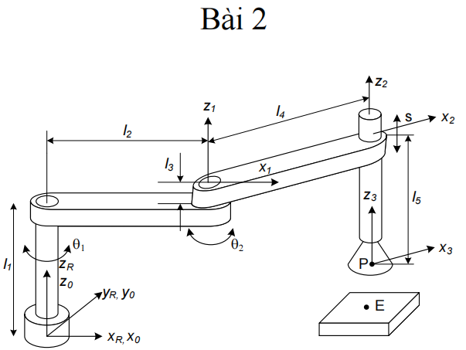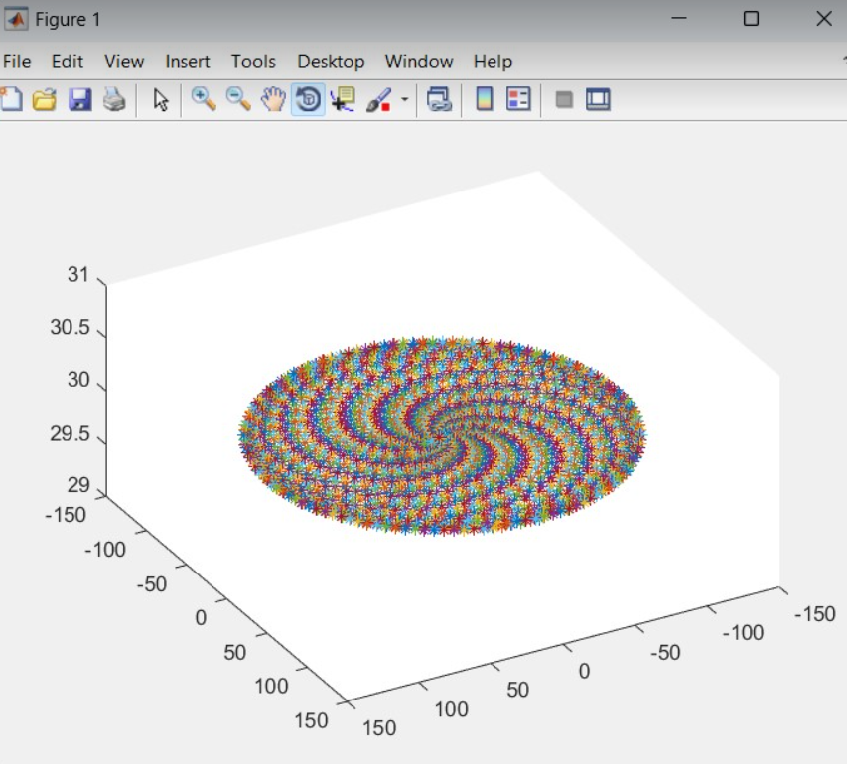

P=T(0,0,l1).R(z,t1).T(l2,0,0).R(z,t2).T(0,0,l3).T(l4,0,0).T5(0,0,-l5).7P

[cos(t1 + t2), -sin(t1 + t2), 0, l4\*cos(t1 + t2) + l2\*cos(t1)]

[sin(t1 + t2), cos(t1 + t2), 0, l4\*sin(t1 + t2) + l2\*sin(t1)]

[ 0, 0, 1, l1 + l3 - l5]

[ 0, 0, 0, 1]

Bài 3:

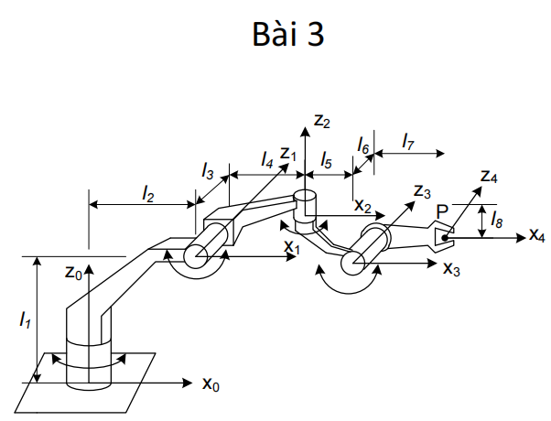

Bài 4:

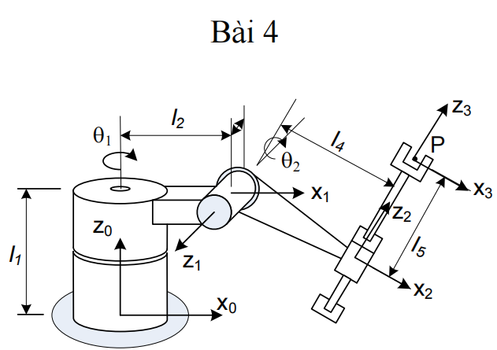

P= T(l1,l2,0).R(z,t1).T(0,0,l3).R(y,t2).T(l4+l5,0,0).R(y,t4).T(l6,0,0).7P

[cos(t2 + t4)\*cos(t1), -sin(t1), sin(t2 + t4)\*cos(t1), l1 + cos(t1)\*cos(t2)\*(l4 + l5) + l6\*cos(t2 + t4)\*cos(t1)]

[cos(t2 + t4)\*sin(t1), cos(t1), sin(t2 + t4)\*sin(t1), l2 + cos(t2)\*sin(t1)\*(l4 + l5) + l6\*cos(t2 + t4)\*sin(t1)]

[ -sin(t2 + t4), 0, cos(t2 + t4), l3 - sin(t2)\*(l4 + l5) - l6\*sin(t2 + t4)]

[ 0, 0, 0, 1]

Bài 5:

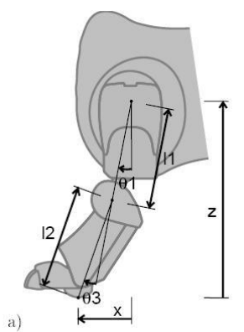

P=R(y,t1).T(0,0,-l1).R(y,t2).T(0,0,-l2).4P

[ cos(t1 + t2), 0, sin(t1 + t2), - l2\*sin(t1 + t2) - l1\*sin(t1)]

[ 0, 1, 0, 0]

[-sin(t1 + t2), 0, cos(t1 + t2), - l2\*cos(t1 + t2) - l1\*cos(t1)]

[ 0, 0, 0, 1]

Bài 6:

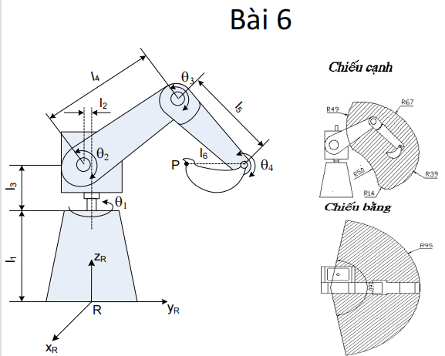

P=T(0,0,l1).R(z,t1).T(0,0,l3).T(0,l2,0).R(x,t2).T(0,0,l4).R(x,t3).T(0,0,l5).R(x,t4).T(0,l6,0).10P

[ cos(t1), -cos(t2 + t3 + t4)\*sin(t1), sin(t2 + t3 + t4)\*sin(t1), sin(t1)\*(l2 + l5\*sin(t2 + t3) + l4\*sin(t2) + l6\*cos(t2 + t3 + t4))]

[ sin(t1), cos(t2 + t3 + t4)\*cos(t1), -sin(t2 + t3 + t4)\*cos(t1), -cos(t1)\*(l2 + l5\*sin(t2 + t3) + l4\*sin(t2) + l6\*cos(t2 + t3 + t4))]

[ 0, sin(t2 + t3 + t4), cos(t2 + t3 + t4), l1 + l3 + l5\*cos(t2 + t3) + l4\*cos(t2) - l6\*sin(t2 + t3 + t4)]

[ 0, 0, 0, 1]

Bài 7,9:

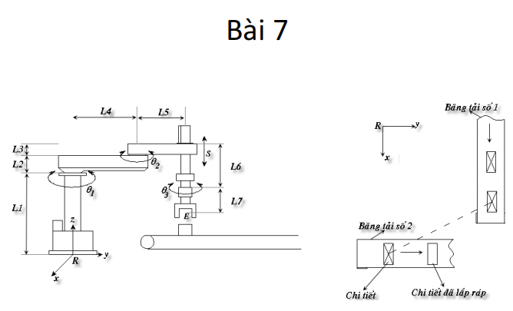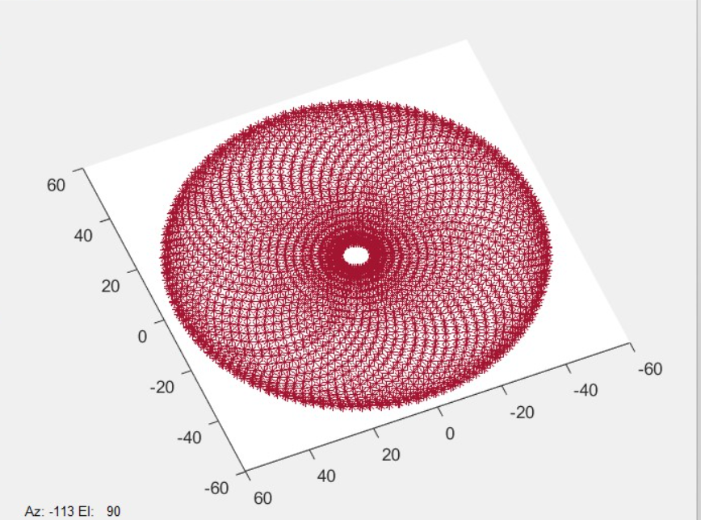

P=T(0,0,l1).R(z,t1).T(0,0,l2).T(0,l4,0).R(x,t2).T(0,0,l3).T(0,l5,0).T(0,0,-l6).R(z,t3).T(0,0,-l7).10P

[ cos(t1 + t2 + t3), -sin(t1 + t2 + t3), 0, - l5\*sin(t1 + t2) - l4\*sin(t1)]

[ sin(t1 + t2 + t3), cos(t1 + t2 + t3), 0, l5\*cos(t1 + t2) + l4\*cos(t1)]

[ 0, 0, 1, l1 + l2 + l3 - l6 - l7]

[ 0, 0, 0, 1]

Bài 8:

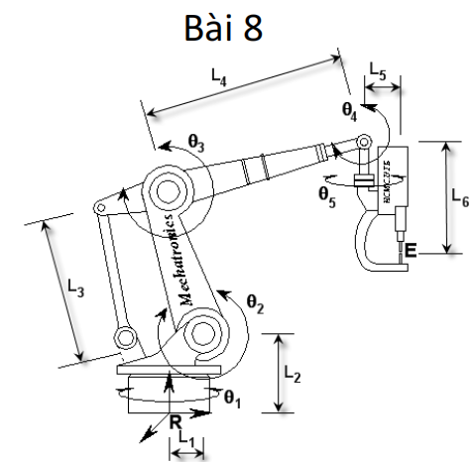

Bài 10:

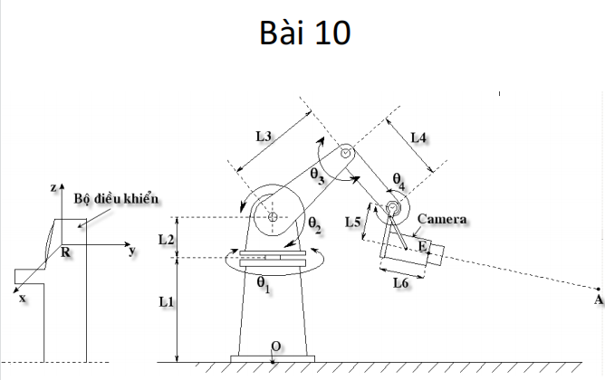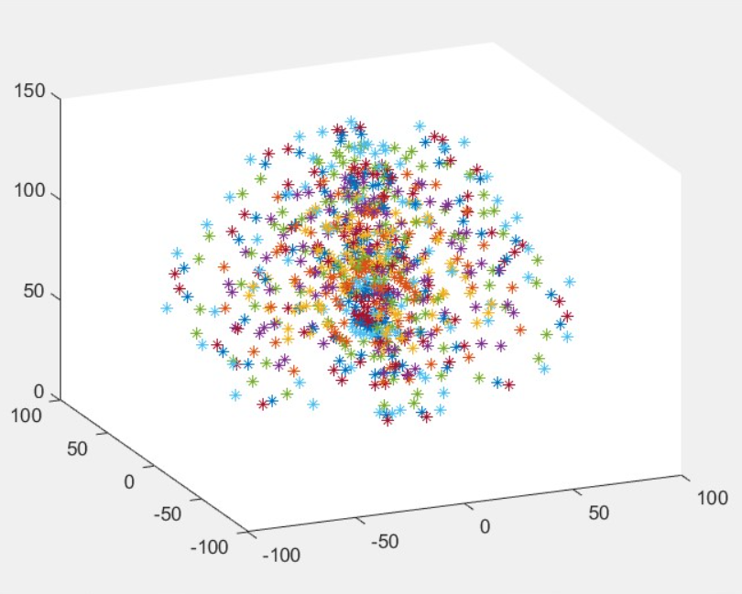

P= T(0,0,l1).R(z,t1).T(0,0,l2).R(x,t2).T(0,l3,0).R(x,t3).T(O,l4,0).R(x,t4).T(0,l5,0).T(0,0,l6).10P

[ cos(t1), -cos(t2 + t3 + t4)\*sin(t1), sin(t2 + t3 + t4)\*sin(t1), -sin(t1)\*(l4\*cos(t2 + t3) + l3\*cos(t2) + l5\*cos(t2 + t3 + t4) - l6\*sin(t2 + t3 + t4))]

[ sin(t1), cos(t2 + t3 + t4)\*cos(t1), -sin(t2 + t3 + t4)\*cos(t1), cos(t1)\*(l4\*cos(t2 + t3) + l3\*cos(t2) + l5\*cos(t2 + t3 + t4) - l6\*sin(t2 + t3 + t4))]

[ 0, sin(t2 + t3 + t4), cos(t2 + t3 + t4), l1 + l2 + l4\*sin(t2 + t3) + l3\*sin(t2) + l6\*cos(t2 + t3 + t4) + l5\*sin(t2 + t3 + t4)]

[ 0, 0, 0, 1]